# Chapter 1: Introduction

## 1.1 Background

Public budgeting is a core function of government, shaping the delivery of services, infrastructure development, and the equitable distribution of national resources. However, in many developing countries, including Uganda, budgeting systems are often constrained by outdated methodologies, limited forecasting capabilities, and rigid allocation frameworks. As a result, fiscal inefficiencies persist — funds are frequently misallocated or underutilized, while certain sectors remain underfunded despite pressing needs.  
  
Globally, a growing number of governments are leveraging Artificial Intelligence (AI) and data-driven decision-making tools to modernize public financial management. For instance:  
**South Korea** operates a highly digitized fiscal system through its Digital Budget and Accounting System (D-Brain). This platform integrates planning, budgeting, accounting, and performance data into a centralized system. While not fully AI-driven yet, the system lays a strong foundation for predictive analytics and future integration of AI-based budget simulations.  
**India** employs machine learning and predictive models in its Ministry of Finance to improve planning for large-scale welfare programs. These models assess sectoral needs and evaluate the fiscal impact of various social schemes.  
**Estonia**, known for pioneering e-governance, uses automated and AI-enhanced systems to monitor decentralized budget execution. The system flags anomalies, suggests adjustments, and allows real-time decision-making based on performance and output data.  
  
These use cases demonstrate the global momentum toward intelligent budgeting ecosystems that not only improve transparency but also enhance responsiveness and performance-based resource allocation.

## 1.2 Problem Statement

In Uganda, the budget planning process remains predominantly static and top-down. While frameworks like the Integrated Financial Management System (IFMS) and the Budget Information Portal have increased transparency and access to data, they still lack intelligent decision support and scenario modeling capabilities. Budget allocations are based on historical figures, with minor adjustments for inflation or donor contributions, leaving little room for real-time adaptation or forward-looking analysis.  
  
Consequently, there’s no systematic way to simulate the impact of different allocation strategies, nor to forecast sectoral performance based on previous budget executions. This results in resource misalignment, underfunding of critical areas, and inefficient public service delivery.  
  
To address these gaps, this study proposes a unified AI-enhanced framework that combines:  
Regression analysis for expenditure forecasting,  
Markov Decision Processes (MDPs) for dynamic multi-period allocation optimization,  
And Monte Carlo simulations for uncertainty modeling and policy scenario evaluation.

### 1.2.1 Uganda’s Current Budgeting Approach: The MTEF

Uganda operates a Medium-Term Expenditure Framework (MTEF) — a multi-year budgeting approach designed to link policy objectives, planning frameworks, and budgeting over a rolling three-year period. The MTEF is intended to promote fiscal discipline and predictability by allowing sectors to plan and justify funding needs based on strategic goals and macroeconomic projections.  
  
While the MTEF has improved structure and consistency in national budgeting, several challenges limit its effectiveness:  
- Projections are manually derived, often lacking rigorous statistical backing or real-time updates.  
- Feedback mechanisms are weak — actual sector performance does not meaningfully influence subsequent allocations.  
- The framework is rigid, with limited capacity to adapt to emerging priorities, shocks, or inefficiencies during execution.  
- No simulation environment exists for testing different policy options or resource distribution strategies.  
  
As such, the proposed AI model is not a replacement for the MTEF but a decision support augmentation, capable of dynamically informing and strengthening its planning assumptions, resource prioritization, and policy foresight.

## 1.3 Objectives of the Study

This research aims to design and evaluate a hybrid AI-based decision support system for government budgeting, integrating three complementary techniques: regression analysis, Markov Decision Processes, and Monte Carlo simulation.  
  
Specifically, the objectives are:  
- To develop a regression model that forecasts expenditure patterns across selected government sectors.  
- To design a Markov Decision Process that simulates and optimizes multi-year budget allocation strategies.  
- To apply Monte Carlo simulations for modeling uncertainty in policy outcomes and transition dynamics.  
- To integrate all three techniques into a unified framework for dynamic, feedback-driven budgeting.  
- To evaluate the hybrid model’s performance against traditional budgeting benchmarks, including historical allocations and MTEF-based projections.

## 1.4 Research Questions

1. How can regression techniques be applied to forecast sectoral expenditure needs?  
2. How can Markov Decision Processes be used to optimize budget allocations under uncertainty?  
3. What value does Monte Carlo simulation add to budget modeling in terms of robustness and scenario planning?  
4. How does the proposed hybrid model compare with traditional frameworks like the MTEF in terms of responsiveness and predictive power?

## 1.5 Scope and Delimitation

This research will focus on three key government sectors — **Health, Education**, and **Agriculture** — chosen for their significant budget allocations and socioeconomic importance. Historical budget data (2010–2024) will be collected from official publications on *budget.go.ug* and *finance.go.ug*.  
  
The model will be developed and tested in a simulation environment. Political negotiations, donor funding conditions, and non-quantifiable strategic factors (like regional balancing) are outside the scope of the study but acknowledged as important real-world constraints.

## 1.6 Significance of the Study

This study contributes to the emerging field of AI in public sector decision-making by offering a structured, testable, and adaptable budget optimization framework. By integrating three powerful modeling techniques — regression, MDP, and Monte Carlo simulation — it supports:  
- More accurate forecasts of sectoral resource needs,  
- Dynamic, reward-based allocation decisions over time,  
- And robust scenario analysis that factors in uncertainty and shocks.  
  
The framework can inform not only central government allocations but also decentralized decision-making at the ministry or agency level, ultimately improving fiscal efficiency, impact, and adaptability in public financial management.

## 1.7 Overview of Core Techniques

In predictive modelling, two fundamental tasks exist — classification and regression. Given the nature of budget forecasts requiring continuous value predictions (e.g., expected expenditures), regression models are employed over classification models.

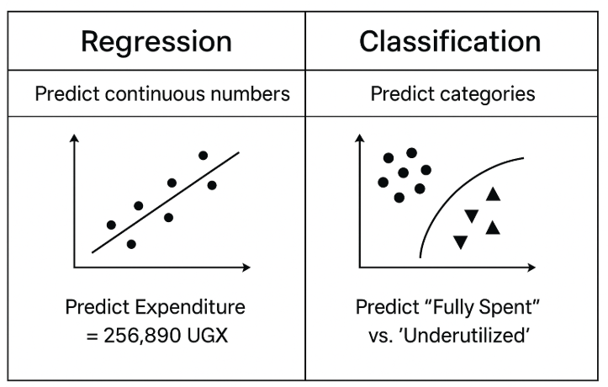

Figure 1: Regression Vs. Classification

### 1.7.1 Regression Analysis

Is the statistical technique that estimates the relationships between a dependent variable (e.g., expenditure) and one or more independent variables (e.g., time, sector, prior performance).  
  
It is to be used to forecast future budget needs of government sectors based on historical expenditure and performance trends and will serve as the input layer for the MDP model.

### 1.7.2 Markov Decision Processes (MDPs)

Is the formalism for modeling decision-making in environments where outcomes are partly random and partly under the control of a decision-maker. It consists of:  
**States:** A sector’s status in a given fiscal year.  
**Actions:** Allocation amounts or policy decisions.  
**Transition probabilities:** Likelihood of moving from one state to another given an action.  
**Rewards**: Expected value or benefit from taking an action in a particular state.  
**Policy:** A strategy that defines what action to take in each state.  
  
The MDP models multi-year sectoral budgeting as a sequence of allocation decisions. It identifies policies that maximize cumulative long-term rewards (e.g., performance, efficiency).

### 1.7.3 Monte Carlo Simulation

Is the probabilistic technique that uses random sampling to simulate thousands of possible outcomes, especially useful when data is incomplete or uncertainty is high.  
  
Monte Carlo simulations are used to estimate MDP transition probabilities and simulate different budgetary paths under uncertainty (e.g., revenue shocks, performance variability). It enhances robustness and supports scenario analysis.

## 1.8 Why Combine All Three?

Each technique addresses a different layer of the budget optimization challenge:  
- Regression gives us accurate forecasts.  
- MDPs enable multi-step, strategic decision modeling.  
- Monte Carlo deals with uncertainty and real-world noise in data.  
  
Used in isolation, each method has limitations:  
- Regression lacks feedback.  
- MDPs require complete transition data.  
- Monte Carlo lacks structure without a defined decision process.  
  
Together, they form a unified, modular framework for smart budgeting — adaptable, explainable, and capable of simulating multiple futures before decisions are made.

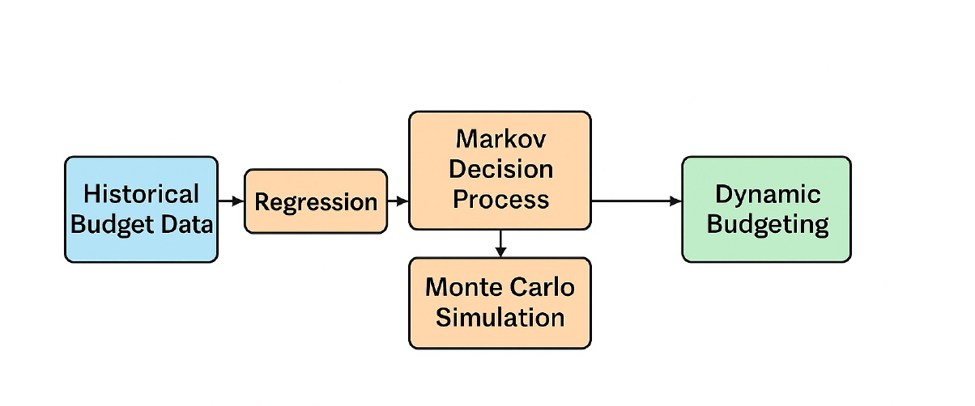

Figure : Conceptual framework for AI-driven budget optimization model

## 1.9 Conclusion

This chapter has introduced the core motivation behind the study: improving government budgeting through a smart, adaptive, and data-driven framework. Despite notable progress in digitizing public financial systems, Uganda’s current tools lack predictive, dynamic, and probabilistic decision-making capabilities. Frameworks like the MTEF provide structure but remain largely static and manual.  
  
By combining regression analysis (to forecast sectoral needs), Markov Decision Processes (to model sequential allocation decisions), and Monte Carlo simulation (to handle stochastic uncertainty), this study proposes a hybrid AI model that augments existing systems and enhances fiscal responsiveness. Stochastic methods are particularly important for modeling real-world randomness — such as revenue shocks, implementation delays, or policy response variability — which traditional deterministic models fail to capture.  
  
This framework is not only technically rigorous but also policy-relevant, offering a pathway toward more efficient and equitable budgeting in the public sector. The next chapter will explore how similar models have been used globally and review the literature supporting the design of each core component.

The following chapter will explore global literature and empirical models that demonstrate the practical use of regression, MDP, and stochastic methods in public sector decision-making.